

Clean

Home

Treatment

For Safe

,

**Healthy**

Living

Ozone shock treatment

Protection from biological threats.



for

Safe,

**Healthy**

Living

Copyright 2006-2009 Thermophoto Inc.

For a free no obligation quote please call:

**519-636-7217**

**www.thermophoto.com**

for Safe

,

**Healthy**

Living

Mold,

**bacteria,**

odour?

Kill, disinfect and eliminate the threat of:

Visible black and toxic mold

Harmful VOC’s and allergens

Bacteria, virus, ecoli

Dust mites, bedbugs, fleas, lice

Bad odours:

smokey, musty, pet, vomit, & more

**We treat:**

Whole homes or individual rooms:

Including attics, basements, and apartments

Office and Work spaces

Boats, cars and trailers

Banquet halls, kitchens, bars and restaurants.

Safe and effective work, GuaranteeD.

Treatment is 100% natural & leaves a fresh scent.

Eliminates microbiological threats & odours.

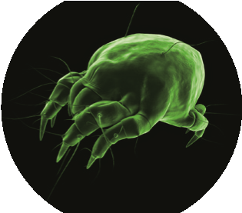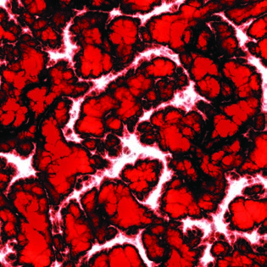

**Eliminates**

the threat of mold and

other harmful allergens even inside

your duct system.

**Kills 99.9%**

of harmful bacterias &

viruses which cause sickness & odours.

**Terminates**

dust mites, fleas, lice,

bed bugs and other house hold pests.