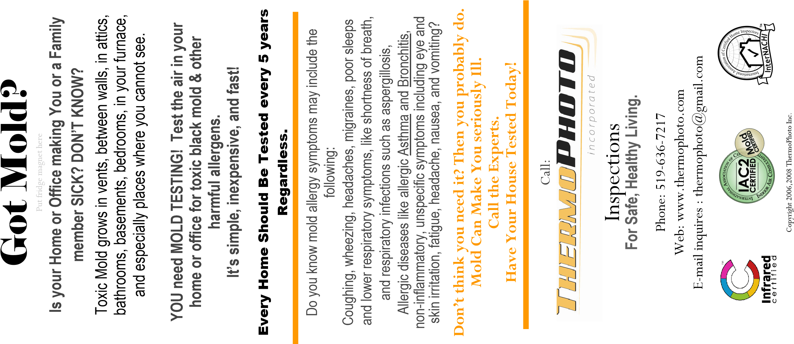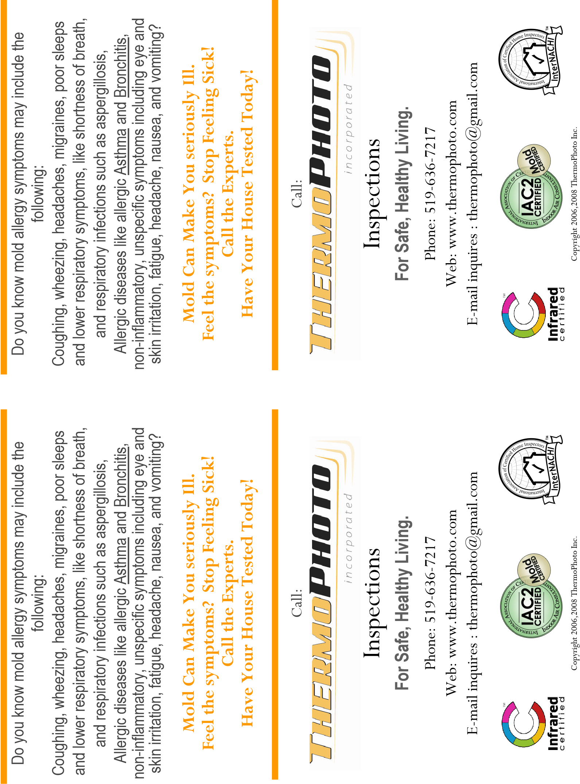

**Is your Home or Office making You or a Family**

**member SICK? DON’T KNOW?**

**YOU need MOLD TESTING? Test the air in your**

**home or office for toxic black mold & other**

**harmful allergens.**

**It’s simple, inexpensive, and fast!**

Got Mold?

Toxic Mold grows in vents, between walls, in attics

,

bathrooms, basements, where you sleep, in your

furnace, and especially places where you cannot see

.

**Is your Home or Office making You or a Family**

**member SICK? DON’T KNOW?**

**YOU need MOLD TESTING? Test the air in your**

**home or office for toxic black mold & other**

**harmful allergens.**

**It’s simple, inexpensive, and fast!**

Got Mold?

Toxic Mold grows in vents, between walls, in attics

,

bathrooms, basements, where you sleep, in your

furnace, and especially places where you cannot see

.